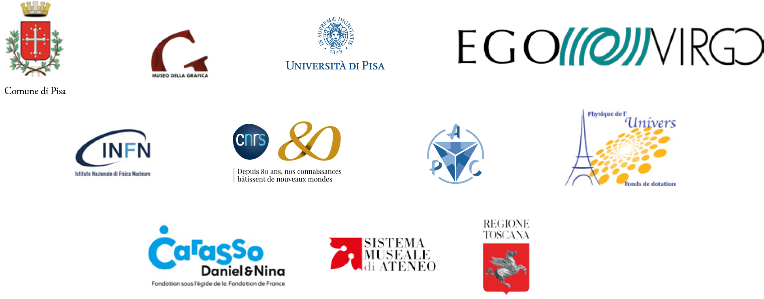

Le rythme de l’espace
Il ritmo dello spazio
The Rhythm Of Space

Art et Science de Marconi aux ondes gravitationnelles

Curator Stavros Katsanevas

12 October – 8 Ddecember 2019

Museo della Grafica – Palazzo Lanfranchi, Pisa

The exhibition offers a fascinating journey through art and science against the background of exciting discoveries in contemporary physics.
On August 14, 2017, the three gravitational wave interferometers LIGO and VIRGO detected the signal produced by the coalescence of two black holes. The era of gravitational astronomy began thanks to triangulation and the consequent localization in the sky of this source. Only three days later, the signal produced by the merger of two neutron stars triggered a huge research campaign in which hundreds of Observatories were involved worldwide. This second event was fully considered the dawn of the so-called multi-messenger astronomy. Einstein's theory of general relativity, which predicts that every violent phenomenon in the universe produces vibrations in space-time, has had an extraordinary confirmation.
The detection of gravitational waves allows us to face from new perspectives the problem of the nature and structure of space-time and matter, the notions of origin and horizon, the role of information and representation, the plasticity and resilience of objects , also touching on aspects related to the individual and more generally to the relationship of man with the Cosmos, that is the Universe, the Earth, the Society.
Born within the project "Univers 2.0", started in 2017 with the support of the Carasso Foundation, the exhibition is the result of the cross-reflection of some artists of international importance with scientists and intellectuals (Valerio Boschi , Arnaud Dubois, Ersi Krouska, Marc Lachièze-Ray, Alain Letailleur, Pierre Legrain, Dorothea Marciak, Roger Malina, Vincenzo Napolano, Stavros Katsanevas, Christian Spiering, Alessandro Tosi, Yves Winkin, Heinz Wismann). The exhibition path, with its evocative conceptual and emotional impact, presents in fact installations, sculptures, videos, graphic works and photographs taken by

Gorka ALDA, Pavel BÜCHLER, Attila CSÖRGŐ, Raphaël DALLAPORTA, Raymond GALLE, Bertrand LAMARCHE, Liliane LIJN, Letizia DE MAIGRET, Aitor ORTIZ, Tomás SARACENO, Jol THOMSON.

The detection of gravitational waves in fact directs towards a description of the Universe in multi-messenger form, or rather the awareness of being part of a cosmic network in which the vibrations of space-time, the "rhythm", the "sound" or the harmony of space are added to the millennial conception of the Universe as a sublime visual representation.
Special attention will be given to the historical forms of communication, through a room set up in partnership with the Marconi station of Coltano, with instruments for the emission and reception of radio waves, as well as a Galena crystal from the Giazotto collection (a special thanks to the Giazotto family). Two other rooms, presented in collaboration with the APC, in Paris, I2PI in Lyon and the INFN, will offer visitors an interactive experience dedicated to the deformation of space.
Curated by Stavros Katsanevas, director of the European Gravitational Observatory (EGO), the exhibition is promoted and implemented by EGO and the Museum of Graphics (Municipality of Pisa, University of Pisa), with the collaboration of the Centre National de Recherche Scientifique (CNRS) , of the National Institute of Nuclear Physics (INFN), of the Laboratory of Astroparticle Physics and Cosmology (APC) of Paris and the Endowment Fund for the Physics of the Universe, of of the Institute of Physics of 2 Infiniti (I2PI) Lyon, of the University Museum System of University of Pisa, with the patronage of the Tuscany Region and the support of the Carasso Foundation.

Exhibition website: https://sites.ego-gw.eu/ilritmodellospazio/

THE RHYTHM OF SPACE
ART AND SCIENCE FROM MARCONI TO GRAVITATIONAL WAVES

PISA, MUSEO DELLA GRAFICA
Palazzo Lanfranchi
Lungarno Galileo Galilei, 9 - 56125 Pisa (PI)
12 October - 8 December 2019

Curated by
Stavros Katsanevas

Assistance to the curator
Ersi Krouska

Organizational coordination
Alice Tavoni

Administrative coordination
Sabrina Balestri, Maria Cioni

Assemblies and fittings
ACME04 srl

Catalog
ETS editions

Editing of texts in French
Dorothea Marciak

Web Design
Sarodia Vydelingum

MUSEO DELLA GRAFICA

Scientific director
Alessandro Tosi

President
Virginia Mancini

Honorary President
Lucia Tongiorgi Tomasi

Referent for the Collections
Alice Tavoni

Administrative Coordination
Sabrina Balestri

Administrative Management
Massimo Baldacci, Maria Cioni, Alessandro Germelli, Sonia Raglianti

Educational laboratories and communication
Fabiana Fiorelli, Elena Profeti, Ilaria Tuci

Timetables
Monday - Sunday: 9.00 - 20.00

Tickets
Full price: € 9.00
Reduced: € 7.00

Information
Museo della Grafica
Tel .: (+39) 050 2216060

email: museodellagrafica@adm.unipi.it
www.museodellagrafica.unipi.it

Facebook | Instagram
#Ondegravitazionali #Black

